RNL-SLM-TRK
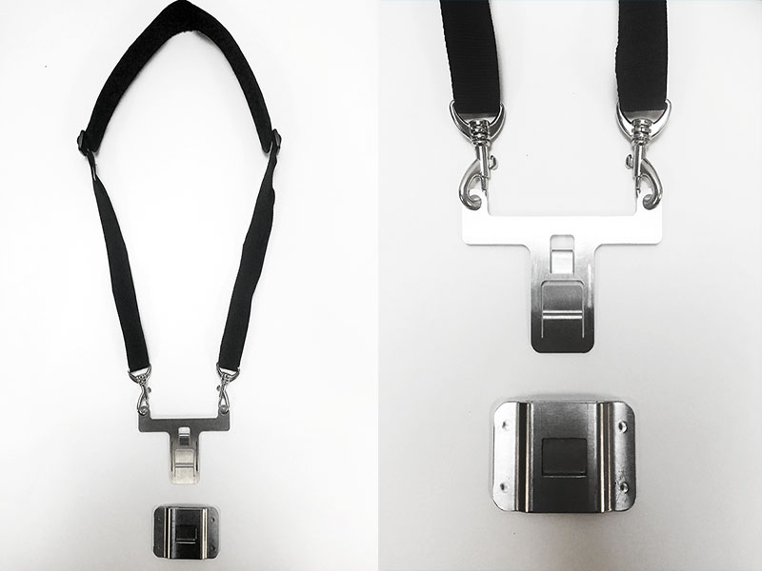
The Universal SlingMount™ is the easiest way to turn any table case into an over the shoulder sling. Simply bond the Mounting Plate to the back of the device case (**Case Not Included – Attaches to Your Case**), then, insert the sling attachment when needed. Ideal for Hospitals or Worksites where cases have been purchased and you are looking for a safer way to carry devices.
The Mounting Plate is the same one used for the HipClip, making the whole system modular.
https://www.mobiletechgear.com/shop/tablet-sling-mount/
Benefits Include:
SlingMount™ allows you to easily carry a table on your belt like any other tool
Easy to assemble Mounting Plate secured with VHB™ peel and bond adhesive [Tensile Strength 90lbs sq/in]
Provides instant access to tablet in less than 1 second
Reduces the probability of loss and theft
Perfect for jobs that require two hands by freeing up an “additional hand”
Eliminates fumbling in cumbersome bags and packs
Available in two tablet sizes: Mini [7″-9″] and Regular [9″-11″]
Ideal for: Builders – Adjusters – Inspectors – Roofers – Electricians – HVAC – Service Tech – Landscapers – Architects – Retailers – Field Workers – Farmers – Medical Professionals

